(Approx. 932 words)

YouTube as a Knowledge Resource
By Tom Burt, Vice-President
Sun City Summerlin Computer Club
https://www.scscc.club tomburt89134 (at) cox.net

YouTube (www.youtube.com) is Google’s online platform for user-created videos. Over the years, users have posted an amazing collection of videos, which grows larger daily. YouTube is my “go-to” resource when I’m looking for arcane bits of knowledge—especially “how-to” examples. This month, we’ll look at a few examples of YouTube videos that quickly convey helpful knowledge in an audiovisual format.

Example 1 – Adjust the Brakes on a Walker

Take, for instance, my 4-wheeled rollator walker. It has brakes for the rear wheels that need tightening every couple of years. I turned to YouTube, entered the phrase “how to adjust brakes on a drive rollator” into the search window, and immediately found several helpful videos. After watching a few to ensure I had all the necessary information, I was able to make the adjustment using just a pair or two of pliers.

Example 2 – Replace the Hard Drive in an HP Laptop with a Solid-State Drive

Among the various computers in Casa de Burt is a 2014 vintage HP Pavilion laptop that originally came with Windows 8. Its disk drive is a 500 G-byte 5400 RPM hard drive. Its CPU is an AMD A8, and it has 4 G bytes of RAM. I upgraded the operating system to Windows 10 in early 2016.

After that upgrade, this laptop became so slow it was almost unusable for about 15 minutes after booting, even with software tuning to minimize Microsoft’s “instrumentation.” After booting, Windows 10 launches a variety of scans of the hard drive, all running simultaneously, that fight each other and overwhelm the system. While this happened, it often took Windows over a minute to respond to a mouse click.

The Computer Club experienced this same effect with laptops in our training lab. The club’s volunteer maintenance team eventually mitigated the problem by installing solid-state drives in those laptops. However, the procedure is complex and requires careful handling and sequencing of the steps to disassemble and reassemble the laptop.

I decided to look into what it would take to upgrade to a solid-state drive on my HP laptop. I browsed YouTube and entered the search phrase: “replace hard drive on hp pavilion 17z laptop”. YouTube offered me a selection of similar searches, one of which I picked. I got an excellent selection of hits on step-by-step” videos that detailed the procedure. I played a few of these to get a sense of how complex the upgrade would be. Ultimately, I decided to pass on the upgrade, not because I felt I couldn’t do it, but because, even after upgrading the laptop with a new SSD, the rest of the system components were over eight years old. The other hardware specs (CPU, RAM, chipset) would not be compatible with Windows 11. I concluded that installing Linux Mint on that laptop in place of Windows 10 would be better.

This was an example of YouTube helping me decide NOT to do something.

Example 3 – Adjusting the Sound Settings on My Samsung Smart TV

A few months ago, I “cut the cord,” abandoning DirecTV in favor of streaming YouTube TV, Paramount+ (CBS), Amazon Prime Video and its companion FreeVee, the free tier of Peacock TV (NBC), and Samsung’s own 100+ channel free streaming TV service. The video quality of these services has been excellent, and I’ve got more content available than I could ever have watched. One frustration, however, has been that the sound level varies a lot between the various services. I must frequently adjust the TV volume depending on which service I’m currently streaming.

I decided to see what YouTube could tell me. I browsed to YouTube and entered the search phrase: “samsung 65 inch tv sound adjustment”. I got several useful hits, as shown below. The middle hit video showed an advanced setting for Adaptive Sound, which I needed.

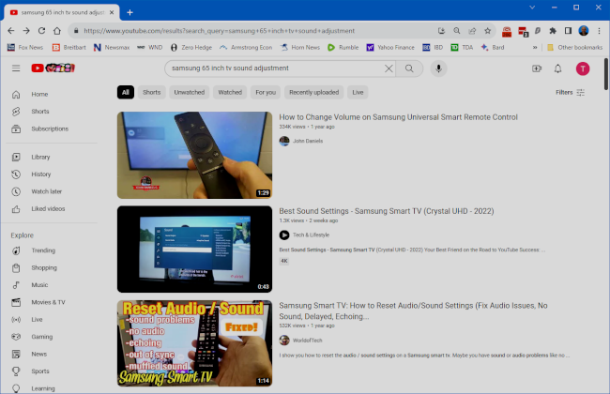

Example 4 – Tutorial on Using Zoom

I do two monthly teaching sessions – one on investing and one on some technology topics of current interest, such as AI, networking, or photo editing. My preferred presentation venue is Zoom, which I can use to teach from my home office. Zoom works well, but one problem has been that some of our Sun City seniors have found getting Zoom to work difficult. It would be nice to teach a class on using Zoom; however, teaching a class on Zoom via Zoom is a classic “Catch-22”. What to do?

I browsed to YouTube and entered the search phrase: “joining a zoom meeting”. I got several helpful video hits. Below is a screenshot of one of the videos.

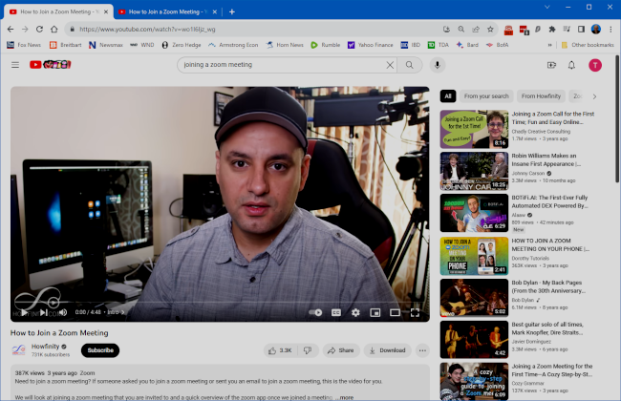

The video was a simple tutorial focusing solely on how a novice user could join a Zoom video session. That is the only procedure my class attendees would need to attend my Zoom sessions. Once I had reviewed the video, I copied the URL of that video so that I could include it in my email notice of the meeting as a helpful tutorial aid for beginners.

Closing Thoughts

The possibilities for finding online tutorials on YouTube are vast, all available for free. Alas, in this article, we’ve barely scratched the surface. A caveat is that, like all Internet content, there’s no guarantee that it’s up-to-date or even factually correct. The quality of videos can vary, and speakers make many with difficult-to-understand accents. Patience is the key to finding the gem that you are seeking.

